1. Find all the topics and tasks which are thought in the month of October  
     
   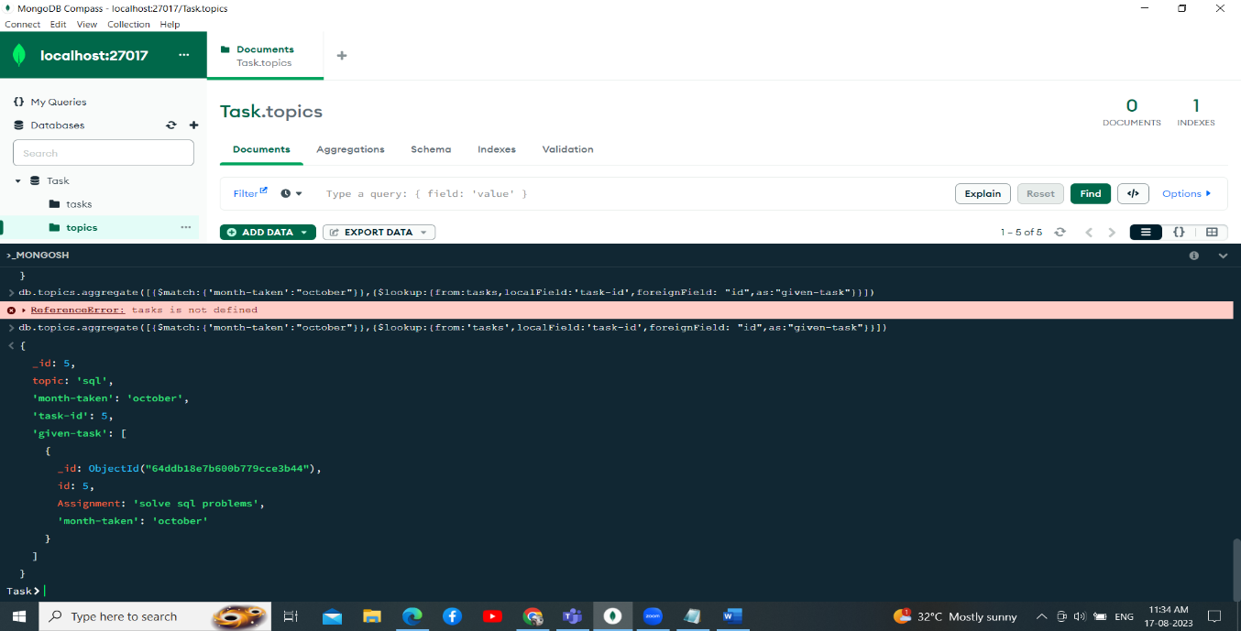

Comment : db.topics.aggregate([{$match:{“month-taken”:”october”}},{$lookup:{from:””tasks”,localField:”task-id”,foreignField:”id”,as:”given-task”}])  
  
2. Find all the company drives which appeared between 15 oct-2020 and 31-oct-2020

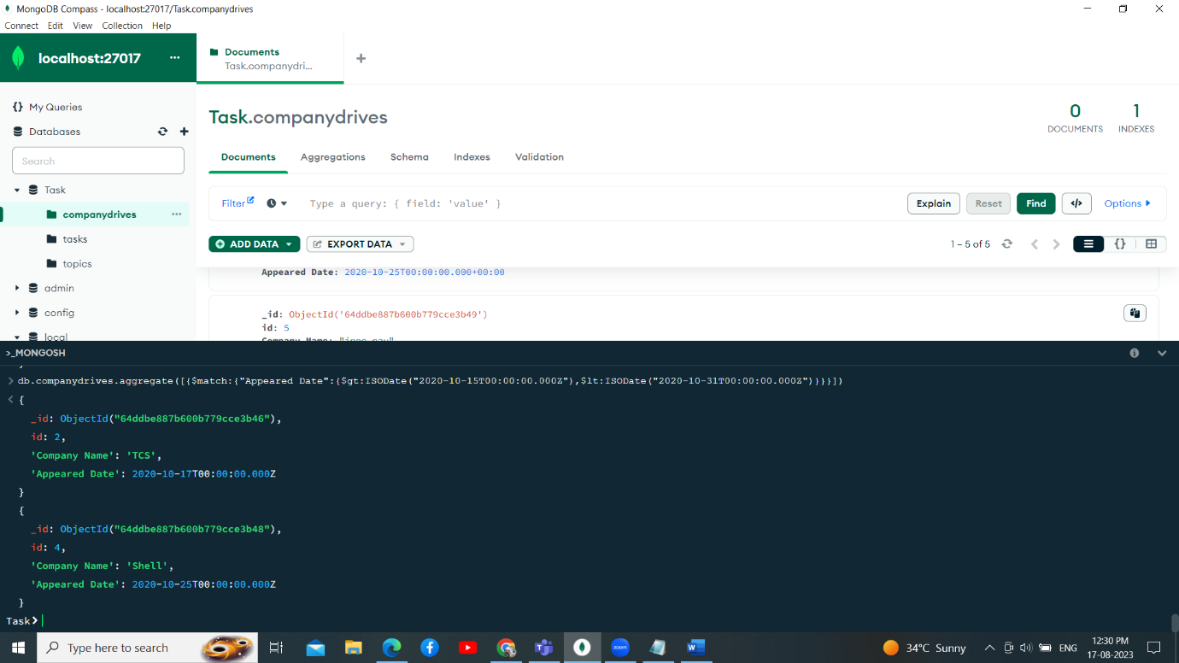

Comment : db.companydrives.aggregate([{$match:{"Appeared Date":{$gt:ISODate("2020-10-15T00:00:00.000Z"),$lt:ISODate("2020-10-31T00:00:00.000Z")}}}])  
  
  
  
  
  
  
  
  
3. Find all the company drives and students who are appeared for the placement.  
  
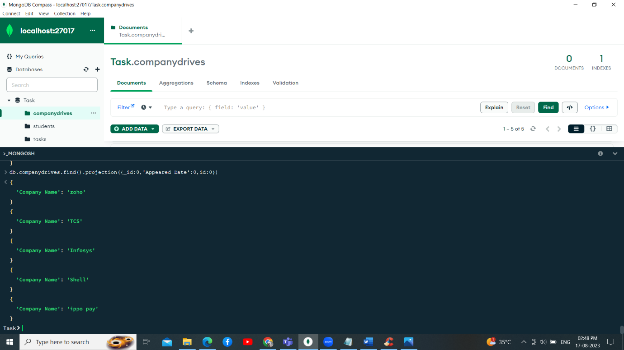

Comment : db.companydrives.find().projection({_id:0,”Appeared Date’:0,id:0})  
  
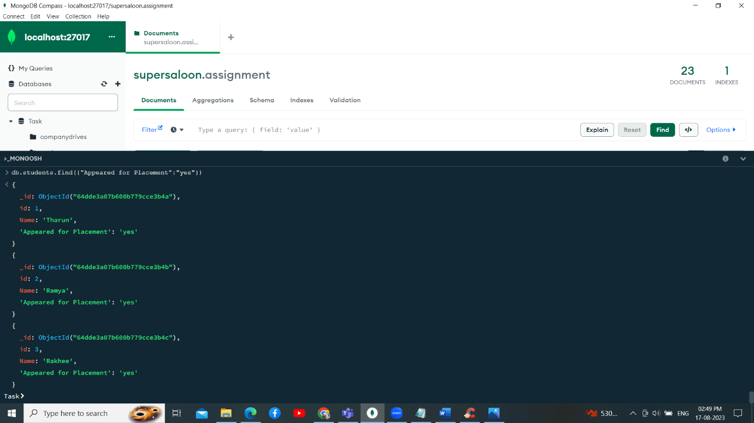  
Comment : db.companydrives.find({“Appeared for Placement”:”yes”})

4. Find the number of problems solved by the user in codekata  
  
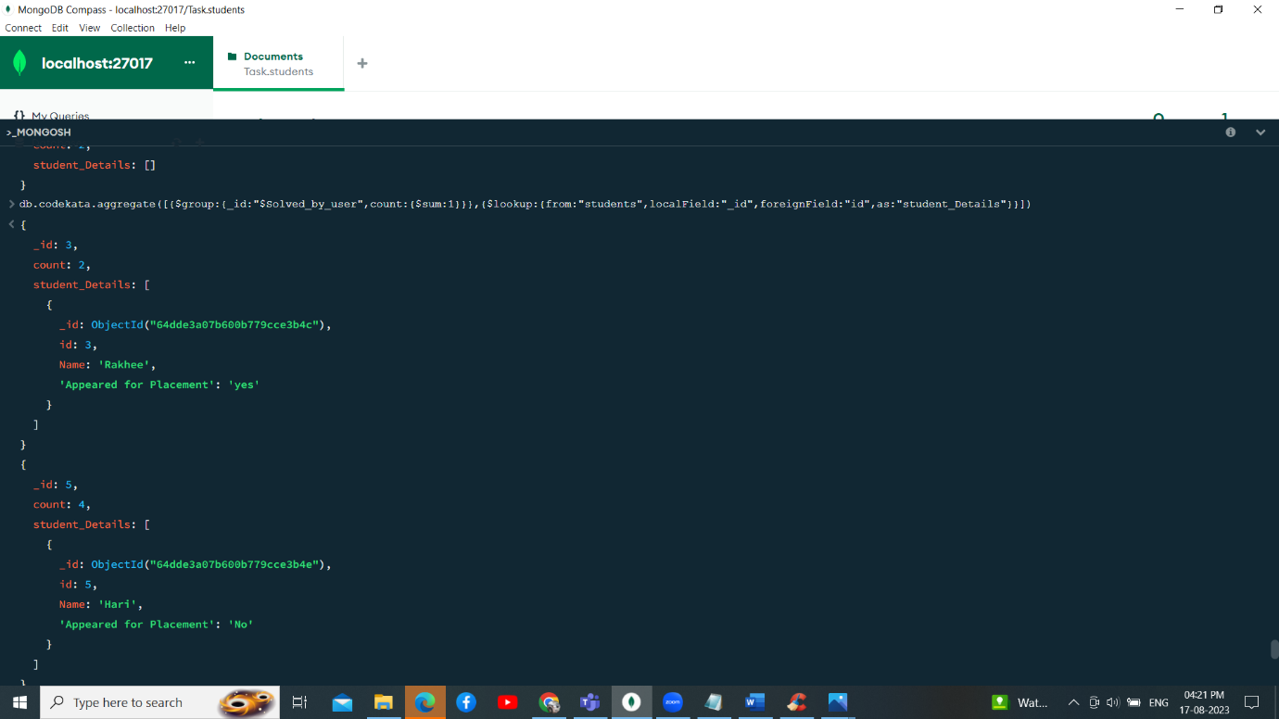

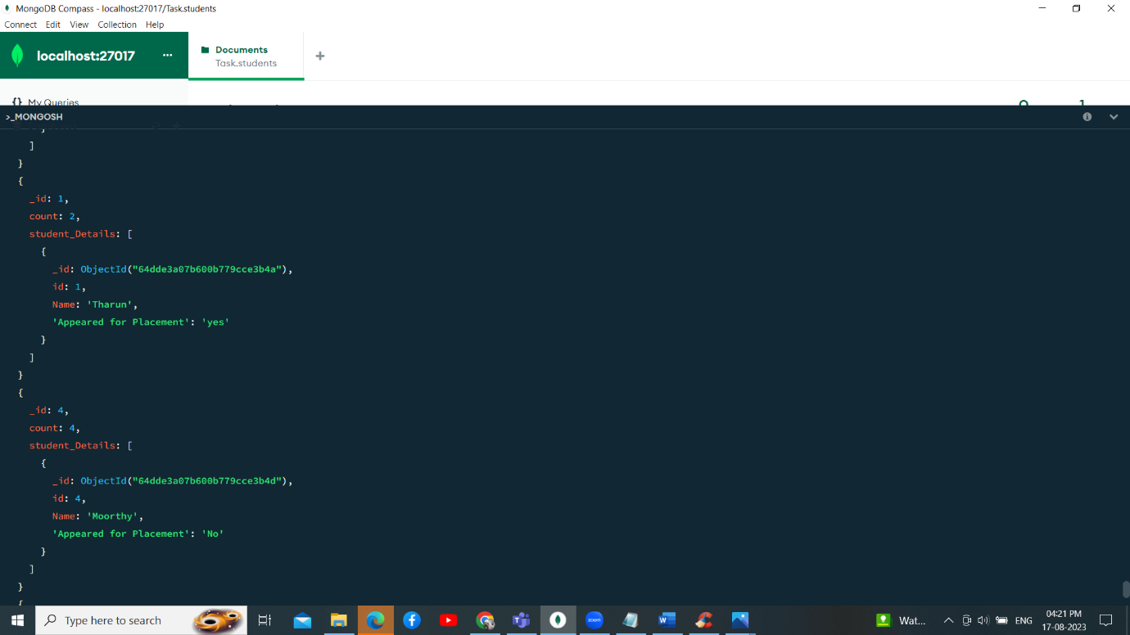  
  
  
  
  
  
  
  
  
  
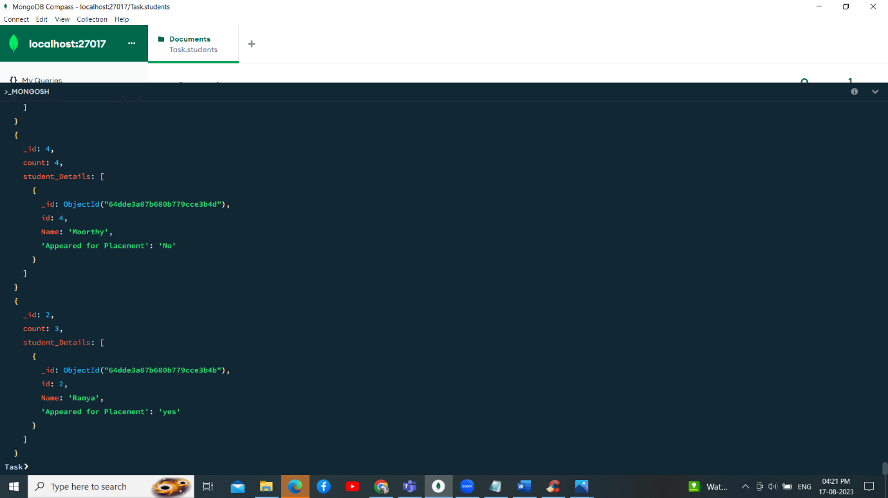  
  
Comment: db.codekata.aggregate([{$group:{_id:"$Solved_by_user",count:{$sum:1}}},{$lookup:{from:"students",localField:"_id",foreignField:"id",as:"student_Details"}}])  
  
5. Find all the mentors with who has the mentee's count more than 15  
  
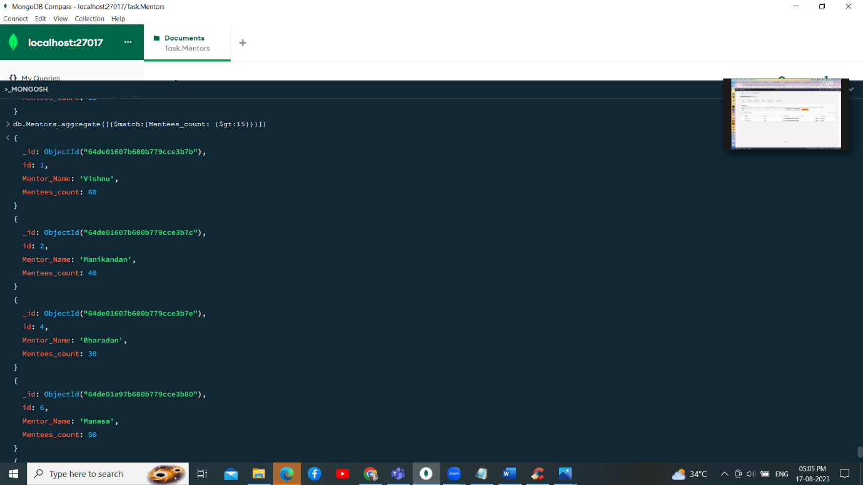

Comment: db.Mentors.aggregate([{$match:{Mentees_count: {$gt:15}}}])

6. Find the number of users who are absent and task is not submitted  between 15 oct-2020 and 31-oct-2020

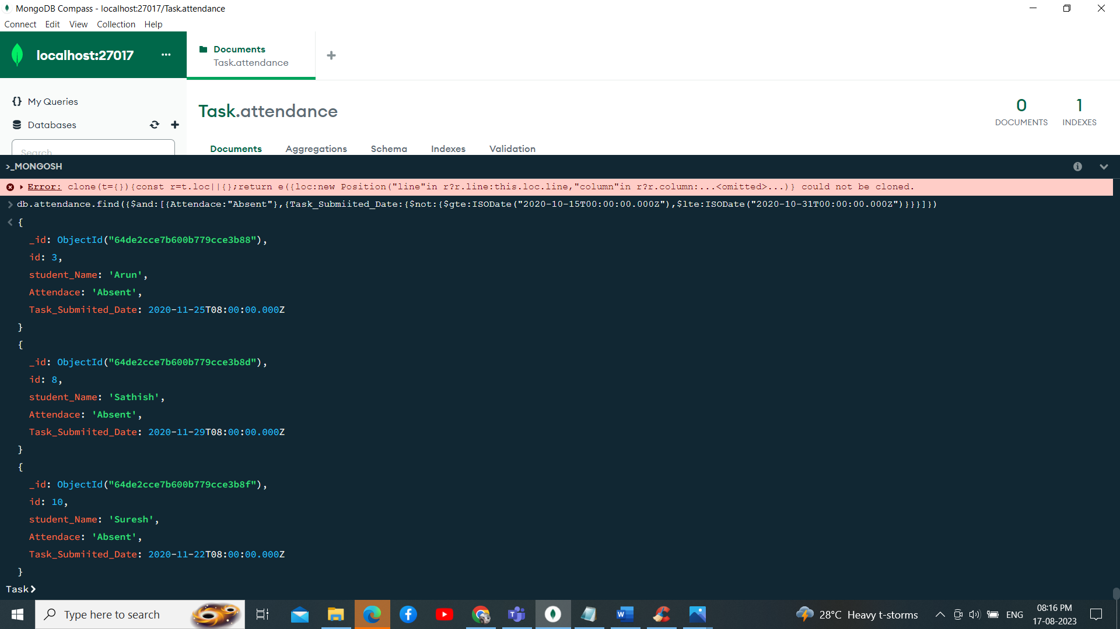  
  
  
Comment: db.attendance.find({$and:[{Attendace:"Absent"},{Task_Submiited_Date:{$not:{$gte:ISODate("2020-10-15T00:00:00.000Z"),$lte:ISODate("2020-10-31T00:00:00.000Z")}}}]})